1. ) What is pH value?

In chemistry, pH, also referred to as acidity, historically denotes "potential of hydrogen". It is a scale used to specify the acidity or basicity of an aqueous solution. A solution with a pH less than 7 is considered acidic; a solution with a pH greater than 7 is considered basic, or alkaline.

1. ) What is transducer and it’s types?

A transducer is an electronic device that converts energy from one form to another. The process of converting energy from one form to another is known as transduction. Some common examples of transducers include loudspeakers, microphones, thermometers and LEDs.

1. ) Working principle of LVDT

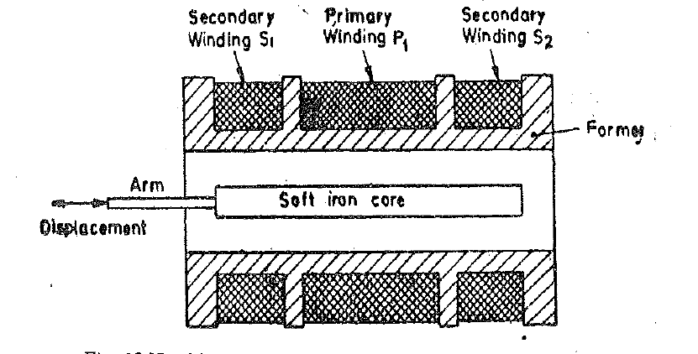

The working principle of LVDT as a displacement transducer is based on mutual induction. When an AC excitation of 5-15 V at a frequency of 50-400Hz is applied to the primary winding, P, a magnetic field is produced. This magnetic field induces a mutual current in the secondary windings, S1 and S2. As a result, the secondary windings have induced voltages of E1 & E2, respectively.

However, both secondary windings are connected in series. Hence, the net output voltage becomes the difference between the induced voltages in the secondary windings. That is, the differential output voltage of the LVDT will be E0 = E1 – E2.

LVDTs, from their construction materials and techniques and fundamental physical principles of operation, have significant uses and benefits in mission-critical applications like Power Generation, Gas and Steam Turbines, Nuclear Turbines, and Aerospace. What’s more, disruption of power electronic modules allows for an easy LVDT calibration process, and, when used properly, they have an endless life cycle.

1. ) RTD

RTD comprises a resistance element and insulated Platinum wires. The resistance element is made of platinum because it is very long-term stable and it has a linear relationship between temperature and resistance, has a wide temperature range and it has a chemical inertness.

In terms of how it works, the RTD follows a basic principle. When the temperature of a metal increases, the resistance to the flow of electricity increases as well. An electrical current is passed through the sensor, the resistance element is used to measure the resistance of the current being passed through it. As the temperature of the resistance element increases the electrical resistance also increases.

The electrical resistance is measured in Ohms. The resistance value can then be converted into temperature based on the characteristics of the element. Usually, the response time for an RTD is between 0.5 and 5 seconds. This makes them very suitable for many applications.

The RTD typically can be used over a higher temperature range than a thermistor, having temperature ranges of −250 to 1000°C. A constant-voltage bridge circuit, similar to that used with strain gages, is usually used for sensing the resistance change that occurs.

1. ) Strain gauge

These are used to measure the strain or deformation in a material caused by a physical force or pressure.

Strain gauges are typically made of a thin wire or foil of a material such as nickel or copper, which is mounted on a flexible backing material.

As the material is subjected to strain, the wire or foil is stretched or compressed, which changes its resistance. This change in resistance can be measured and used to calculate the strain.

Strain gauges can monitor the wing deflection or deformation during flight to ensure it is safe. They also monitor various on-board units and power supplies. Rail applications – strain gauges can be bonded to the railway lines themselves to monitor and measure the stress the lines are under.

1. ) What is Conductance?

Electrical conductance (or electrical conductivity) is the ability of a solution to conduct an electrical current. By inserting two electrodes into distilled water a direct current does not flow through, but if the solution contains electrolytes the electrical current flows through the salt solution.

1. ) Transducers and Types:
   1. Resistive Transducer:
      1. Potentiometruc Type
      2. Strain Guage
         1. Bounded and Unbounded
         2. Piezo-Resistve Strain
            1. N-type
            2. P-type
2. Inductive Type Transducers
   1. Self Generating
   2. Non-self Generating
3. Capacitive Type
   1. Parallel plate capacitance with rectangular plates.
   2. Cylindrical capacitor transducer.
   3. Semi circular parallel plates.
   4. Change in dielectric between parallel plates.
4. ) Zener Diode

A Zener diode is a special type of diode designed to reliably allow current to flow "backwards" when a certain set reverse voltage, known as the Zener voltage, is reached. Zener diodes are manufactured with a great variety of Zener voltages and some are even variable.

1. ) PLC

The PLC receives information from connected sensors or input devices, processes the data, and triggers outputs based on pre-programmed parameters.

Depending on the inputs and outputs, a PLC can monitor and record run-time data such as machine productivity or operating temperature, automatically start and stop processes, generate alarms if a machine malfunctions, and more. Programmable Logic Controllers are a flexible and robust control solution, adaptable to almost any application.